

Department of Computer Science

Assignment 4
Name:
Eisha Asim
Roll no.
243575
Sumbitted to:
Sir Faisal Idrees

Models

Citizen Model
using System.ComponentModel.DataAnnotations;

namespace Assignment_4.Models
{
public class CitizenModel
{
[Key]
public int CitizenId { get; set; }

[Required]
[StringLength(100)]
public string FullName { get; set; } = string.Empty;

[Required]
[StringLength(15)]
public string CNIC { get; set; } = string.Empty;

[Required]
[StringLength(100)]
public string FatherName { get; set; } = string.Empty;

[Required]
public DateTime DateOfBirth { get; set; }

[Required]
[StringLength(10)]
public string Gender { get; set; } = string.Empty;

[Required]
[StringLength(200)]
public string Address { get; set; } = string.Empty;

[StringLength(20)]
public string MaritalStatus { get; set; } = string.Empty;

[StringLength(50)]
public string Nationality { get; set; } = "Pakistani";

public bool IsAlive { get; set; } = true;

public DateTime CreatedDate { get; set; } = DateTime.Now;

public ICollection<CitizenUpdateRequestModel> UpdateRequests { get; set; } = new List<CitizenUpdateRequestModel>();
}
}

Citizen update Request Model
using System.ComponentModel.DataAnnotations;
using System.ComponentModel.DataAnnotations.Schema;

namespace Assignment_4.Models
{
public class CitizenUpdateRequestModel
{
[Key]
public int RequestId { get; set; }

[Required]
[ForeignKey("CitizenModel")]
public int CitizenId { get; set; }

[Required]
[ForeignKey("DepartmentModel")]
public int RequestedByDepartmentId { get; set; }

[Required]
[StringLength(50)]
public string RequestedField { get; set; } = string.Empty;

[StringLength(500)]
public string OldValue { get; set; } = string.Empty;

[Required]
[StringLength(500)]
public string NewValue { get; set; } = string.Empty;

[Required]
[StringLength(20)]
public string Status { get; set; } = "Pending";

public DateTime RequestedDate { get; set; } = DateTime.Now;

public CitizenModel Citizen { get; set; } = null!;
public DepartmentModel Department { get; set; } = null!;
}
}

Department Model

using System.ComponentModel.DataAnnotations;

namespace Assignment_4.Models
{
public class DepartmentModel
{
[Key]
public int DepartmentId { get; set; }

[Required]
[StringLength(100)]
public string DepartmentName { get; set; } = string.Empty;

[Required]
[StringLength(50)]
public string DepartmentType { get; set; } = string.Empty;

public bool IsActive { get; set; } = true;

public ICollection<CitizenUpdateRequestModel> UpdateRequests { get; set; } = new List<CitizenUpdateRequestModel>();
}
}

Controllers

Authentication
using Microsoft.AspNetCore.Identity;
using Microsoft.AspNetCore.Mvc;
using Microsoft.IdentityModel.Tokens;
using System.IdentityModel.Tokens.Jwt;
using System.Security.Claims;
using System.Text;
using Assignment_4.DTOs;
using Assignment_4.Data;
using Microsoft.EntityFrameworkCore;

namespace Assignment_4.Controllers
{
[ApiController]
[Route("api/[controller]")]
public class AuthController : ControllerBase
{
private readonly UserManager<IdentityUser> _userManager;
private readonly SignInManager<IdentityUser> _signInManager;
private readonly RoleManager<IdentityRole> _roleManager;
private readonly IConfiguration _configuration;
private readonly ApplicationDbContext _context;

public AuthController(
UserManager<IdentityUser> userManager,
SignInManager<IdentityUser> signInManager,
RoleManager<IdentityRole> roleManager,
IConfiguration configuration,
ApplicationDbContext context)
{
_userManager = userManager;
_signInManager = signInManager;
_roleManager = roleManager;
_configuration = configuration;
_context = context;
}

[HttpPost("register")]
public async Task<IActionResult> Register([FromBody] RegisterDto model)
{
if (ModelState.IsValid == false)
{
return BadRequest(ModelState);
}

var user = new IdentityUser
{
UserName = model.Username,
Email = model.Email
};

var result = await _userManager.CreateAsync(user, model.Password);

if (result.Succeeded == false)
{
return BadRequest(result.Errors);
}

if (await _roleManager.RoleExistsAsync(model.Role) == false)
{
await _roleManager.CreateAsync(new IdentityRole(model.Role));
}

await _userManager.AddToRoleAsync(user, model.Role);

if (model.DepartmentId.HasValue)
{
var department = await _context.Departments.FindAsync(model.DepartmentId.Value);
if (department == null)
{
return BadRequest("Department not found");
}
}

return Ok(new { Message = "User registered successfully" });
}

[HttpPost("login")]
public async Task<IActionResult> Login([FromBody] LoginDto model)
{
if (ModelState.IsValid == false)
{
return BadRequest(ModelState);
}

var user = await _userManager.FindByNameAsync(model.Username);
if (user == null)
{
return Unauthorized("Invalid credentials");
}

var result = await _signInManager.CheckPasswordSignInAsync(user, model.Password, false);
if (result.Succeeded == false)
{
return Unauthorized("Invalid credentials");
}

var roles = await _userManager.GetRolesAsync(user);
var token = GenerateJwtToken(user, roles);

return Ok(new AuthResponseDto
{
Token = token,
Username = user.UserName!,
Role = roles.FirstOrDefault() ?? "",
Expires = DateTime.UtcNow.AddHours(24)
});
}

private string GenerateJwtToken(IdentityUser user, IList<string> roles)
{
var claims = new List<Claim>
{
new Claim(ClaimTypes.NameIdentifier, user.Id),
new Claim(ClaimTypes.Name, user.UserName!),
new Claim(JwtRegisteredClaimNames.Jti, Guid.NewGuid().ToString())
};

foreach (var role in roles)
{
claims.Add(new Claim(ClaimTypes.Role, role));
}

var key = new SymmetricSecurityKey(Encoding.UTF8.GetBytes(_configuration["Jwt:Key"]!));
var credentials = new SigningCredentials(key, SecurityAlgorithms.HmacSha256);

var token = new JwtSecurityToken(
issuer: _configuration["Jwt:Issuer"],
audience: _configuration["Jwt:Audience"],
claims: claims,
expires: DateTime.UtcNow.AddHours(24),
signingCredentials: credentials
);

return new JwtSecurityTokenHandler().WriteToken(token);
}
}
}

Citizen
using Microsoft.AspNetCore.Authorization;
using Microsoft.AspNetCore.Mvc;
using Microsoft.EntityFrameworkCore;
using Assignment_4.Data;
using Assignment_4.DTOs;
using Assignment_4.Models;

namespace Assignment_4.Controllers
{
[ApiController]
[Route("api/[controller]")]
[Authorize]
public class CitizenController : ControllerBase
{
private readonly ApplicationDbContext _context;

public CitizenController(ApplicationDbContext context)
{
_context = context;
}

[HttpPost]
[Authorize(Roles = "Admin,DepartmentOfficer")]
public async Task<IActionResult> CreateCitizen([FromBody] CreateCitizenDto dto)
{
if (ModelState.IsValid == false)
{
return BadRequest(ModelState);
}

var existingCitizen = await _context.Citizens.FirstOrDefaultAsync(c => c.CNIC == dto.CNIC);
if (existingCitizen != null)
{
return BadRequest("CNIC already exists");
}

var citizen = new CitizenModel
{
FullName = dto.FullName,
CNIC = dto.CNIC,
FatherName = dto.FatherName,
DateOfBirth = dto.DateOfBirth,
Gender = dto.Gender,
Address = dto.Address,
MaritalStatus = dto.MaritalStatus,
Nationality = dto.Nationality,
IsAlive = dto.IsAlive,
CreatedDate = DateTime.Now
};

_context.Citizens.Add(citizen);
await _context.SaveChangesAsync();

return Ok(new CitizenResponseDto
{
CitizenId = citizen.CitizenId,
FullName = citizen.FullName,
CNIC = citizen.CNIC,
FatherName = citizen.FatherName,
DateOfBirth = citizen.DateOfBirth,
Gender = citizen.Gender,
Address = citizen.Address,
MaritalStatus = citizen.MaritalStatus,
Nationality = citizen.Nationality,
IsAlive = citizen.IsAlive,
CreatedDate = citizen.CreatedDate
});
}

[HttpGet]
[Authorize(Roles = "Admin")]
public async Task<IActionResult> GetAllCitizens()
{
var citizens = await _context.Citizens.ToListAsync();
var response = citizens.Select(c => new CitizenResponseDto
{
CitizenId = c.CitizenId,
FullName = c.FullName,
CNIC = c.CNIC,
FatherName = c.FatherName,
DateOfBirth = c.DateOfBirth,
Gender = c.Gender,
Address = c.Address,
MaritalStatus = c.MaritalStatus,
Nationality = c.Nationality,
IsAlive = c.IsAlive,
CreatedDate = c.CreatedDate
}).ToList();

return Ok(response);
}

[HttpGet("{id}")]
[Authorize(Roles = "Admin,DepartmentOfficer")]
public async Task<IActionResult> GetCitizen(int id)
{
var citizen = await _context.Citizens.FindAsync(id);
if (citizen == null)
{
return NotFound();
}

return Ok(new CitizenResponseDto
{
CitizenId = citizen.CitizenId,
FullName = citizen.FullName,
CNIC = citizen.CNIC,
FatherName = citizen.FatherName,
DateOfBirth = citizen.DateOfBirth,
Gender = citizen.Gender,
Address = citizen.Address,
MaritalStatus = citizen.MaritalStatus,
Nationality = citizen.Nationality,
IsAlive = citizen.IsAlive,
CreatedDate = citizen.CreatedDate
});
}

[HttpPut("{id}")]
[Authorize(Roles = "Admin")]
public async Task<IActionResult> UpdateCitizen(int id, [FromBody] UpdateCitizenDto dto)
{
var citizen = await _context.Citizens.FindAsync(id);
if (citizen == null)
{
return NotFound();
}

if (dto.FullName != null) citizen.FullName = dto.FullName;
if (dto.FatherName != null) citizen.FatherName = dto.FatherName;
if (dto.Gender != null) citizen.Gender = dto.Gender;
if (dto.Address != null) citizen.Address = dto.Address;
if (dto.MaritalStatus != null) citizen.MaritalStatus = dto.MaritalStatus;
if (dto.Nationality != null) citizen.Nationality = dto.Nationality;
if (dto.IsAlive.HasValue) citizen.IsAlive = dto.IsAlive.Value;

await _context.SaveChangesAsync();

return Ok(new CitizenResponseDto
{
CitizenId = citizen.CitizenId,
FullName = citizen.FullName,
CNIC = citizen.CNIC,
FatherName = citizen.FatherName,
DateOfBirth = citizen.DateOfBirth,
Gender = citizen.Gender,
Address = citizen.Address,
MaritalStatus = citizen.MaritalStatus,
Nationality = citizen.Nationality,
IsAlive = citizen.IsAlive,
CreatedDate = citizen.CreatedDate
});
}

[HttpDelete("{id}")]
[Authorize(Roles = "Admin")]
public async Task<IActionResult> DeactivateCitizen(int id)
{
var citizen = await _context.Citizens.FindAsync(id);
if (citizen == null)
{
return NotFound();
}

citizen.IsAlive = false;
await _context.SaveChangesAsync();

return Ok(new { Message = "Citizen deactivated successfully" });
}
}
}

Update
using Microsoft.AspNetCore.Authorization;
using Microsoft.AspNetCore.Mvc;
using Microsoft.EntityFrameworkCore;
using System.Security.Claims;
using Assignment_4.Data;
using Assignment_4.DTOs;
using Assignment_4.Models;

namespace Assignment_4.Controllers
{
[ApiController]
[Route("api/[controller]")]
[Authorize]
public class UpdateRequestController : ControllerBase
{
private readonly ApplicationDbContext _context;
private readonly IHttpContextAccessor _httpContextAccessor;

public UpdateRequestController(ApplicationDbContext context, IHttpContextAccessor httpContextAccessor)
{
_context = context;
_httpContextAccessor = httpContextAccessor;
}

[HttpPost]
[Authorize(Roles = "DepartmentOfficer")]
public async Task<IActionResult> CreateUpdateRequest([FromBody] CreateUpdateRequestDto dto)
{
if (ModelState.IsValid == false)
{
return BadRequest(ModelState);
}

var citizen = await _context.Citizens.FindAsync(dto.CitizenId);
if (citizen == null)
{
return NotFound("Citizen not found");
}

if (dto.RequestedField == "CNIC" || dto.RequestedField == "DateOfBirth")
{
return BadRequest("CNIC and DateOfBirth cannot be updated");
}

var userId = _httpContextAccessor.HttpContext?.User.FindFirstValue(ClaimTypes.NameIdentifier);
if (userId == null)
{
return Unauthorized();
}

var department = await _context.Departments.FirstOrDefaultAsync();
if (department == null)
{
return BadRequest("Department not found");
}

var oldValue = GetPropertyValue(citizen, dto.RequestedField);

var request = new CitizenUpdateRequestModel
{
CitizenId = dto.CitizenId,
RequestedByDepartmentId = department.DepartmentId,
RequestedField = dto.RequestedField,
OldValue = oldValue ?? "",
NewValue = dto.NewValue,
Status = "Pending",
RequestedDate = DateTime.Now
};

_context.UpdateRequests.Add(request);
await _context.SaveChangesAsync();

return Ok(new UpdateRequestResponseDto
{
RequestId = request.RequestId,
CitizenId = request.CitizenId,
CitizenName = citizen.FullName,
DepartmentName = department.DepartmentName,
RequestedField = request.RequestedField,
OldValue = request.OldValue,
NewValue = request.NewValue,
Status = request.Status,
RequestedDate = request.RequestedDate
});
}

[HttpGet]
[Authorize(Roles = "DepartmentOfficer")]
public async Task<IActionResult> GetMyRequests()
{
var userId = _httpContextAccessor.HttpContext?.User.FindFirstValue(ClaimTypes.NameIdentifier);
if (userId == null)
{
return Unauthorized();
}

var department = await _context.Departments.FirstOrDefaultAsync();
if (department == null)
{
return Ok(new List<UpdateRequestResponseDto>());
}

var requests = await _context.UpdateRequests
.Include(r => r.Citizen)
.Include(r => r.Department)
.Where(r => r.RequestedByDepartmentId == department.DepartmentId)
.ToListAsync();

var response = requests.Select(r => new UpdateRequestResponseDto
{
RequestId = r.RequestId,
CitizenId = r.CitizenId,
CitizenName = r.Citizen.FullName,
DepartmentName = r.Department.DepartmentName,
RequestedField = r.RequestedField,
OldValue = r.OldValue,
NewValue = r.NewValue,
Status = r.Status,
RequestedDate = r.RequestedDate
}).ToList();

return Ok(response);
}

[HttpGet("all")]
[Authorize(Roles = "Admin")]
public async Task<IActionResult> GetAllRequests()
{
var requests = await _context.UpdateRequests
.Include(r => r.Citizen)
.Include(r => r.Department)
.ToListAsync();

var response = requests.Select(r => new UpdateRequestResponseDto
{
RequestId = r.RequestId,
CitizenId = r.CitizenId,
CitizenName = r.Citizen.FullName,
DepartmentName = r.Department.DepartmentName,
RequestedField = r.RequestedField,
OldValue = r.OldValue,
NewValue = r.NewValue,
Status = r.Status,
RequestedDate = r.RequestedDate
}).ToList();

return Ok(response);
}

[HttpPost("approve-reject")]
[Authorize(Roles = "Admin")]
public async Task<IActionResult> ApproveRejectRequest([FromBody] ApproveRejectRequestDto dto)
{
if (ModelState.IsValid == false)
{
return BadRequest(ModelState);
}

var request = await _context.UpdateRequests
.Include(r => r.Citizen)
.FirstOrDefaultAsync(r => r.RequestId == dto.RequestId);

if (request == null)
{
return NotFound("Request not found");
}

if (request.Status != "Pending")
{
return BadRequest("Request is already processed");
}

if (dto.Action == "Approve")
{
request.Status = "Approved";
SetPropertyValue(request.Citizen, request.RequestedField, request.NewValue);
await _context.SaveChangesAsync();
}
else if (dto.Action == "Reject")
{
request.Status = "Rejected";
await _context.SaveChangesAsync();
}
else
{
return BadRequest("Action must be 'Approve' or 'Reject'");
}

return Ok(new UpdateRequestResponseDto
{
RequestId = request.RequestId,
CitizenId = request.CitizenId,
CitizenName = request.Citizen.FullName,
DepartmentName = request.Department.DepartmentName,
RequestedField = request.RequestedField,
OldValue = request.OldValue,
NewValue = request.NewValue,
Status = request.Status,
RequestedDate = request.RequestedDate
});
}

private string? GetPropertyValue(CitizenModel citizen, string propertyName)
{
var property = typeof(CitizenModel).GetProperty(propertyName);
if (property == null) return null;
var value = property.GetValue(citizen);
return value?.ToString();
}

private void SetPropertyValue(CitizenModel citizen, string propertyName, string value)
{
var property = typeof(CitizenModel).GetProperty(propertyName);
if (property == null) return;

if (property.PropertyType == typeof(string))
{
property.SetValue(citizen, value);
}
else if (property.PropertyType == typeof(bool))
{
property.SetValue(citizen, bool.Parse(value));
}
else if (property.PropertyType == typeof(DateTime))
{
property.SetValue(citizen, DateTime.Parse(value));
}
}
}
}

Verification
using Microsoft.AspNetCore.Authorization;
using Microsoft.AspNetCore.Mvc;
using Microsoft.EntityFrameworkCore;
using Assignment_4.Data;
using Assignment_4.DTOs;

namespace Assignment_4.Controllers
{
[ApiController]
[Route("api/[controller]")]
[Authorize(Roles = "Admin,DepartmentOfficer")]
public class VerificationController : ControllerBase
{
private readonly ApplicationDbContext _context;

public VerificationController(ApplicationDbContext context)
{
_context = context;
}

[HttpPost("verify")]
public async Task<IActionResult> VerifyCitizen([FromBody] VerifyCitizenDto dto)
{
if (ModelState.IsValid == false)
{
return BadRequest(ModelState);
}

var citizen = await _context.Citizens
.FirstOrDefaultAsync(c => c.CNIC == dto.CNIC);

if (citizen == null)
{
return NotFound("Citizen not found with this CNIC");
}

return Ok(new CitizenResponseDto
{
CitizenId = citizen.CitizenId,
FullName = citizen.FullName,
CNIC = citizen.CNIC,
FatherName = citizen.FatherName,
DateOfBirth = citizen.DateOfBirth,
Gender = citizen.Gender,
Address = citizen.Address,
MaritalStatus = citizen.MaritalStatus,
Nationality = citizen.Nationality,
IsAlive = citizen.IsAlive,
CreatedDate = citizen.CreatedDate
});
}
}
}

DB Context
using Microsoft.AspNetCore.Identity;
using Microsoft.AspNetCore.Identity.EntityFrameworkCore;
using Microsoft.EntityFrameworkCore;
using Assignment_4.Models;

namespace Assignment_4.Data
{
public class ApplicationDbContext : IdentityDbContext<IdentityUser>
{
public ApplicationDbContext(DbContextOptions<ApplicationDbContext> options) : base(options)
{
}

public DbSet<CitizenModel> Citizens { get; set; }
public DbSet<DepartmentModel> Departments { get; set; }
public DbSet<CitizenUpdateRequestModel> UpdateRequests { get; set; }

protected override void OnModelCreating(ModelBuilder builder)
{
base.OnModelCreating(builder);

builder.Entity<CitizenModel>(entity =>
{
entity.HasIndex(e => e.CNIC).IsUnique();
entity.Property(e => e.CNIC).IsRequired();
});

builder.Entity<CitizenUpdateRequestModel>(entity =>
{
entity.HasOne(d => d.Citizen)
.WithMany(p => p.UpdateRequests)
.HasForeignKey(d => d.CitizenId)
.OnDelete(DeleteBehavior.Restrict);

entity.HasOne(d => d.Department)
.WithMany(p => p.UpdateRequests)
.HasForeignKey(d => d.RequestedByDepartmentId)
.OnDelete(DeleteBehavior.Restrict);
});
}
}
}

Program.cs
using Microsoft.AspNetCore.Authentication.JwtBearer;
using Microsoft.AspNetCore.Identity;
using Microsoft.EntityFrameworkCore;
using Microsoft.IdentityModel.Tokens;
using Microsoft.OpenApi.Models;
using System.Text;
using Assignment_4.Data;
using Assignment_4.Models;

var builder = WebApplication.CreateBuilder(args);

builder.Services.AddControllers();
builder.Services.AddEndpointsApiExplorer();
builder.Services.AddHttpContextAccessor();

builder.Services.AddSwaggerGen(c =>
{
c.SwaggerDoc("v1", new OpenApiInfo { Title = "NADRA API", Version = "v1" });
c.AddSecurityDefinition("Bearer", new OpenApiSecurityScheme
{
Description = "JWT Authorization header using the Bearer scheme",
Name = "Authorization",
In = ParameterLocation.Header,
Type = SecuritySchemeType.ApiKey,
Scheme = "Bearer"
});
c.AddSecurityRequirement(new OpenApiSecurityRequirement
{
{
new OpenApiSecurityScheme
{
Reference = new OpenApiReference
{
Type = ReferenceType.SecurityScheme,
Id = "Bearer"
}
},
Array.Empty<string>()
}
});
});

builder.Services.AddDbContext<ApplicationDbContext>(options =>
options.UseSqlServer(builder.Configuration.GetConnectionString("DefaultConnection")));

builder.Services.AddIdentity<IdentityUser, IdentityRole>(options =>
{
options.Password.RequireDigit = true;
options.Password.RequireLowercase = true;
options.Password.RequireUppercase = true;
options.Password.RequireNonAlphanumeric = false;
options.Password.RequiredLength = 6;
})
.AddEntityFrameworkStores<ApplicationDbContext>()
.AddDefaultTokenProviders();

builder.Services.AddAuthentication(options =>
{
options.DefaultAuthenticateScheme = JwtBearerDefaults.AuthenticationScheme;
options.DefaultChallengeScheme = JwtBearerDefaults.AuthenticationScheme;
options.DefaultScheme = JwtBearerDefaults.AuthenticationScheme;
})
.AddJwtBearer(options =>
{
options.SaveToken = true;
options.RequireHttpsMetadata = false;
options.TokenValidationParameters = new TokenValidationParameters
{
ValidateIssuer = true,
ValidateAudience = true,
ValidateLifetime = true,
ValidateIssuerSigningKey = true,
ValidIssuer = builder.Configuration["Jwt:Issuer"],
ValidAudience = builder.Configuration["Jwt:Audience"],
IssuerSigningKey = new SymmetricSecurityKey(Encoding.UTF8.GetBytes(builder.Configuration["Jwt:Key"]!))
};
});

builder.Services.AddAuthorization();

var app = builder.Build();

if (app.Environment.IsDevelopment())
{
app.UseSwagger();
app.UseSwaggerUI();
}

if (app.Environment.IsDevelopment() == false)
{
app.UseHttpsRedirection();
}
app.UseAuthentication();
app.UseAuthorization();
app.MapControllers();

try
{
using (var scope = app.Services.CreateScope())
{
var services = scope.ServiceProvider;
var context = services.GetRequiredService<ApplicationDbContext>();
var roleManager = services.GetRequiredService<RoleManager<IdentityRole>>();

await context.Database.EnsureCreatedAsync();

if (await roleManager.RoleExistsAsync("Admin") == false)
{
await roleManager.CreateAsync(new IdentityRole("Admin"));
}

if (await roleManager.RoleExistsAsync("DepartmentOfficer") == false)
{
await roleManager.CreateAsync(new IdentityRole("DepartmentOfficer"));
}

if (context.Departments.Any() == false)
{
context.Departments.AddRange(
new DepartmentModel { DepartmentName = "Union Council", DepartmentType = "Government", IsActive = true },
new DepartmentModel { DepartmentName = "Bank", DepartmentType = "Financial", IsActive = true },
new DepartmentModel { DepartmentName = "Police", DepartmentType = "Law Enforcement", IsActive = true }
);
await context.SaveChangesAsync();
}
}
}
catch (Exception ex)
{
var logger = app.Services.GetRequiredService<ILogger<Program>>();
logger.LogError(ex, "An error occurred while initializing the database.");
}

app.Run();

App Json

{
"ConnectionStrings": {
"DefaultConnection": "Server=DESKTOP-44MO1B2\\SQLEXPRESS;Database=NADRADb;Trusted_Connection=True;MultipleActiveResultSets=true;Connection Timeout=30;TrustServerCertificate=True"
},
"Jwt": {
"Key": "ThisIsMySecretKeyForJWTTokenGeneration123456789",
"Issuer": "NADRAApi",
"Audience": "NADRAClient"
},
"Logging": {
"LogLevel": {
"Default": "Information",
"Microsoft.AspNetCore": "Warning"
}
},
"AllowedHosts": "*"
}

Screenshots

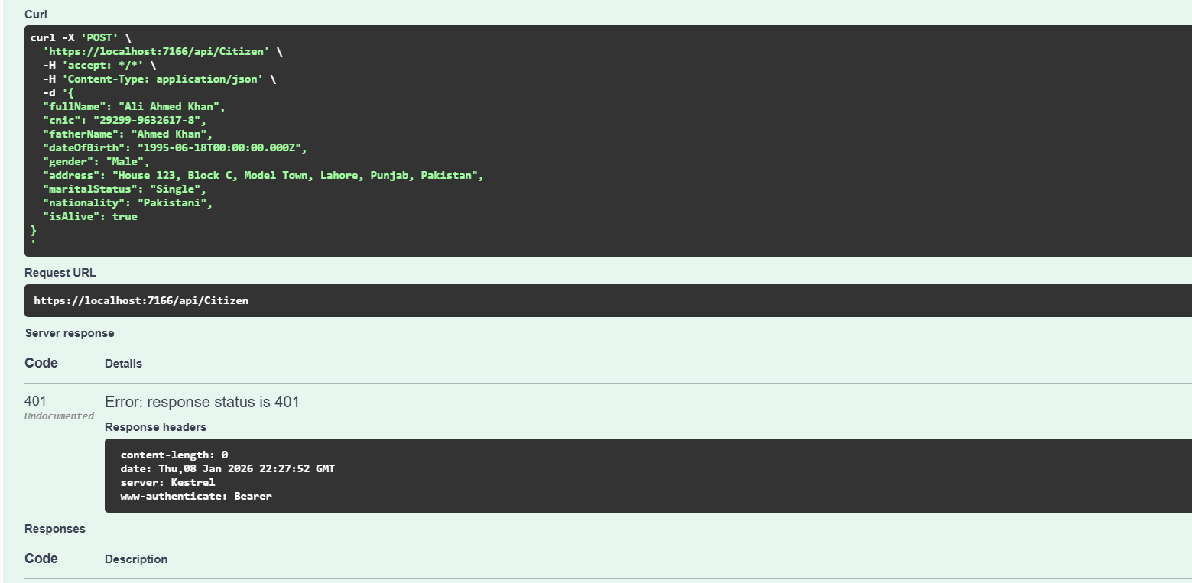
Not working without authentication

Authentication
{
"username": "eisha",
"email": "eisha@example.com",
"password": "securePassword123",
"role": "Admin",
"departmentId": 1
} 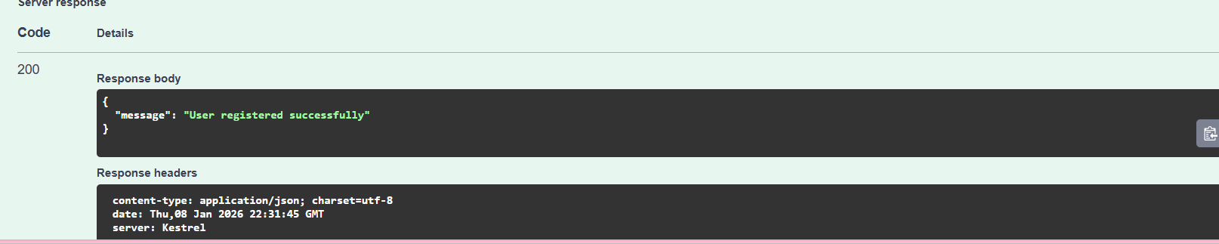
Login:
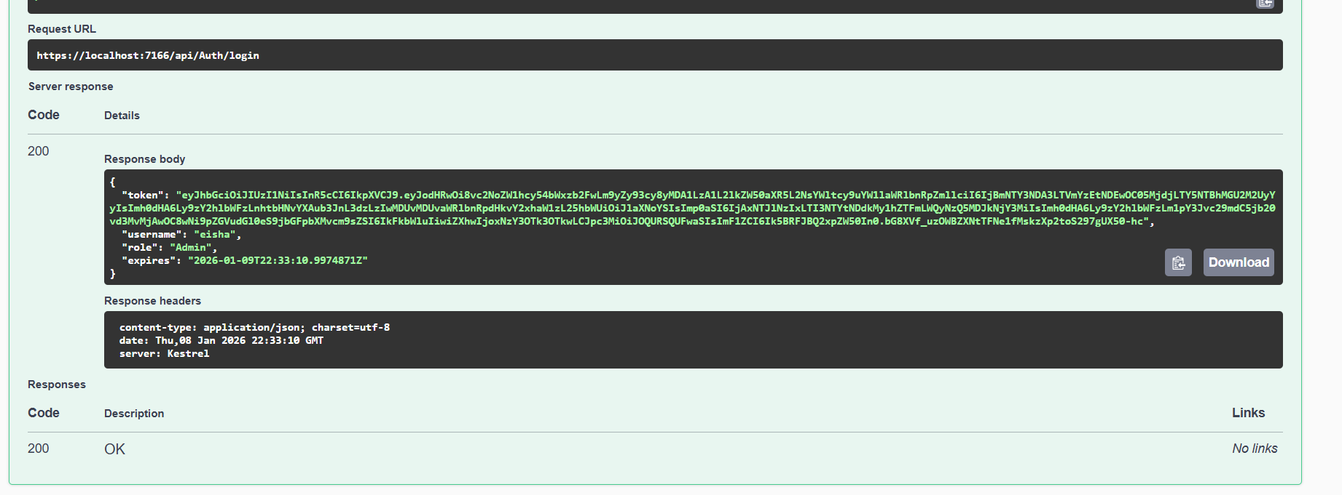
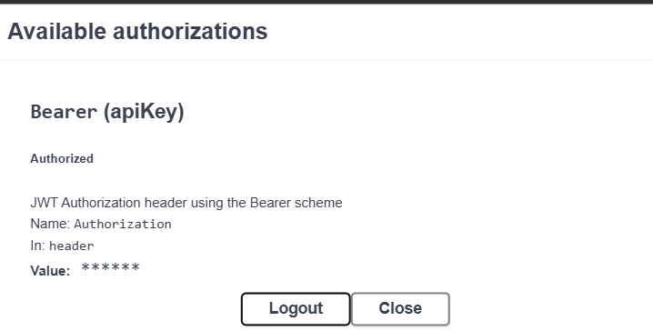

Citizen

Add
{
"fullName": "Ali Ahmed Khan",
"cnic": "29299-9632617-8",
"fatherName": "Ahmed Khan",
"dateOfBirth": "1995-06-18T00:00:00.000Z",
"gender": "Male",
"address": "House 123, Block C, Model Town, Lahore, Punjab, Pakistan",
"maritalStatus": "Single",
"nationality": "Pakistani",
"isAlive": true
}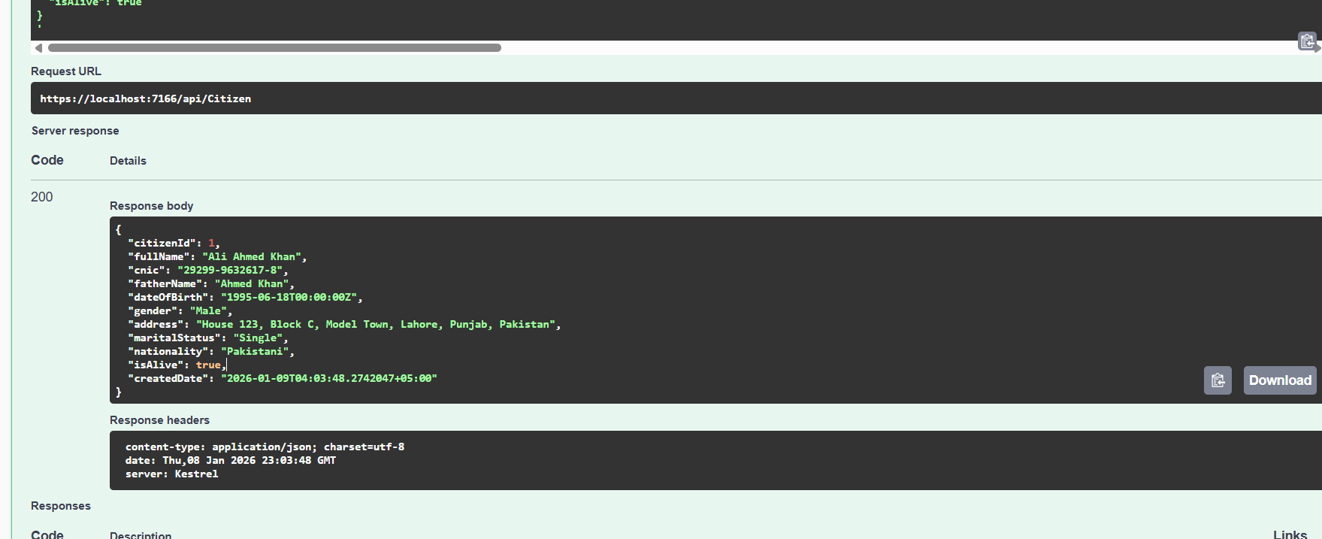

Get

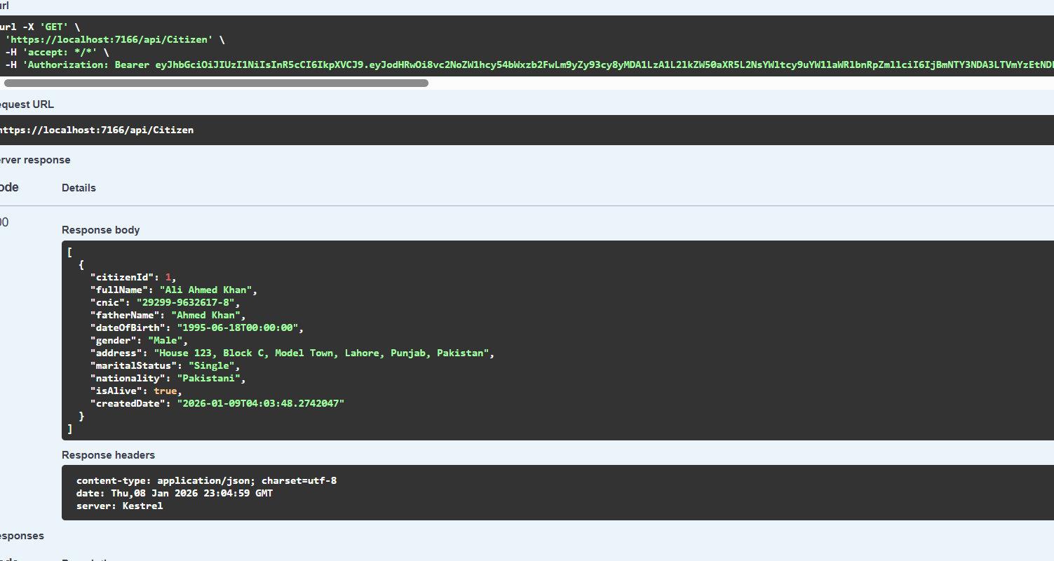

Get By ID

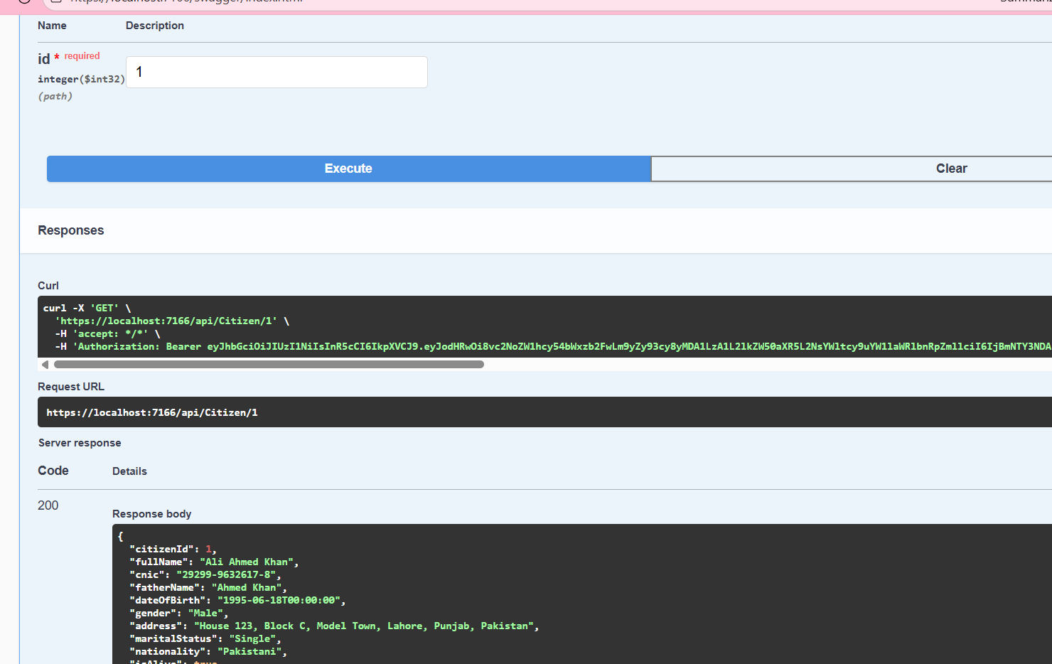Update

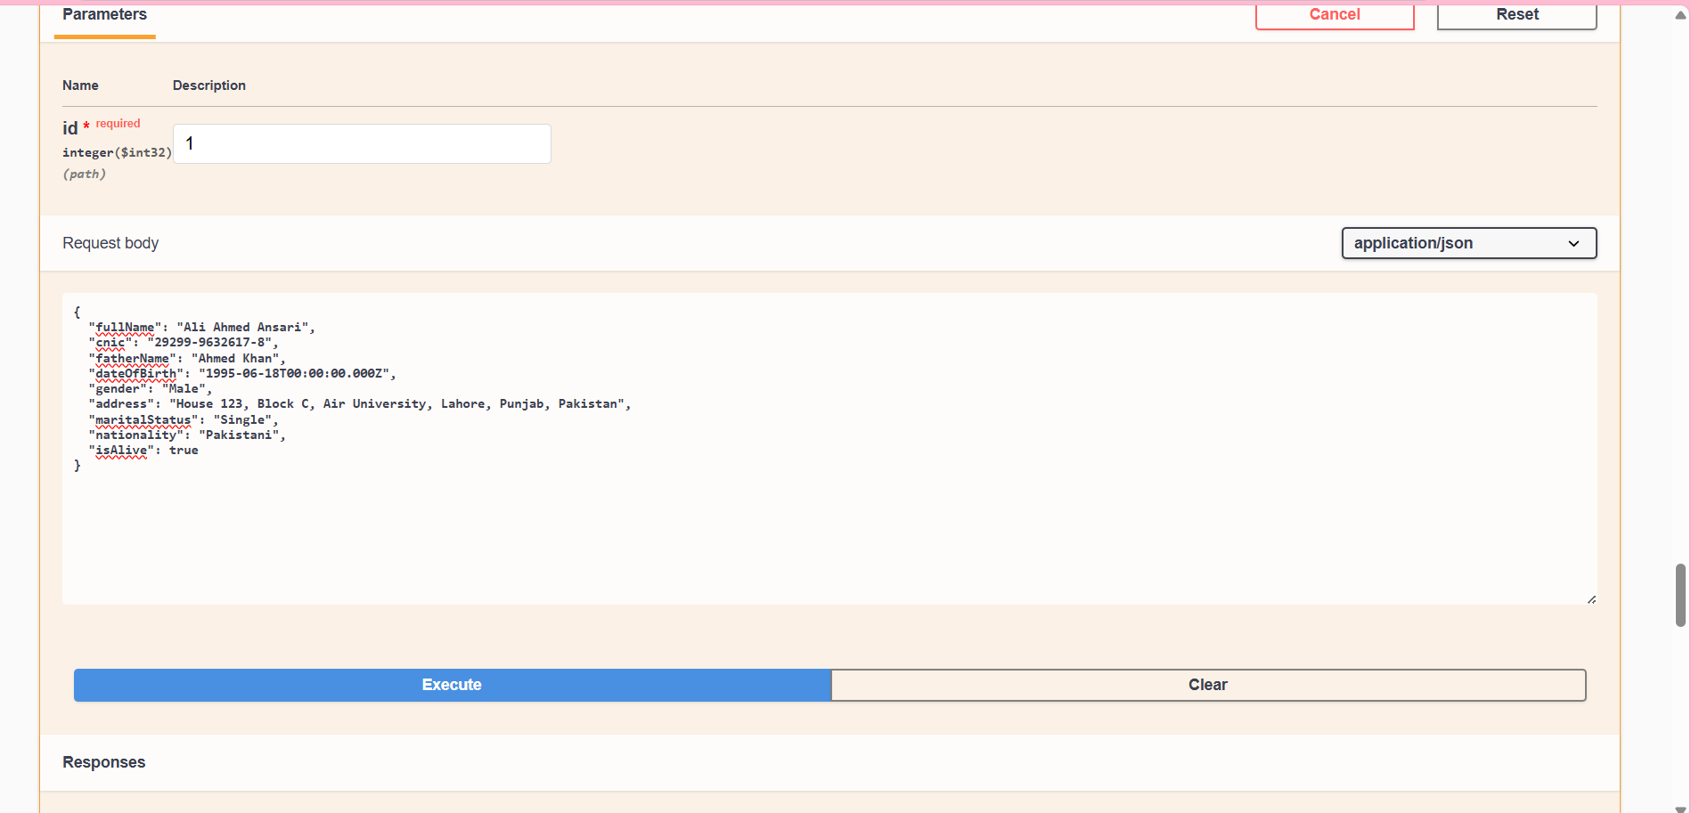

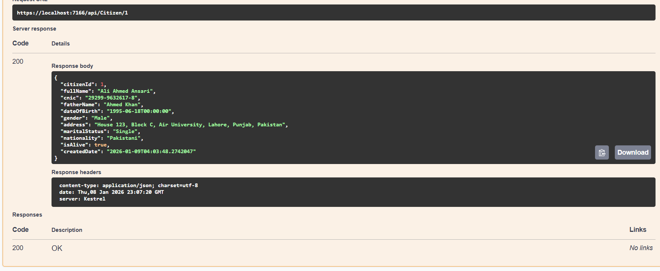

Delete

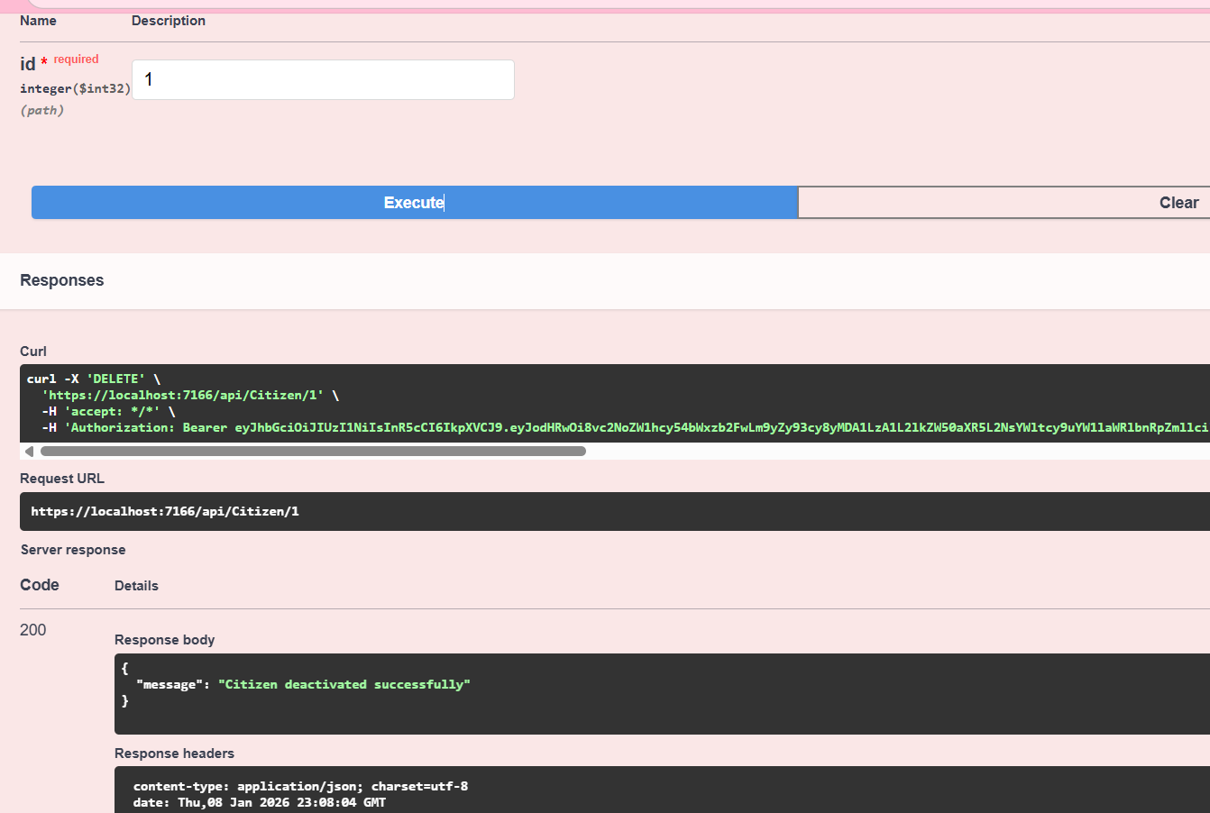
First login as department officers

Update Request

Post

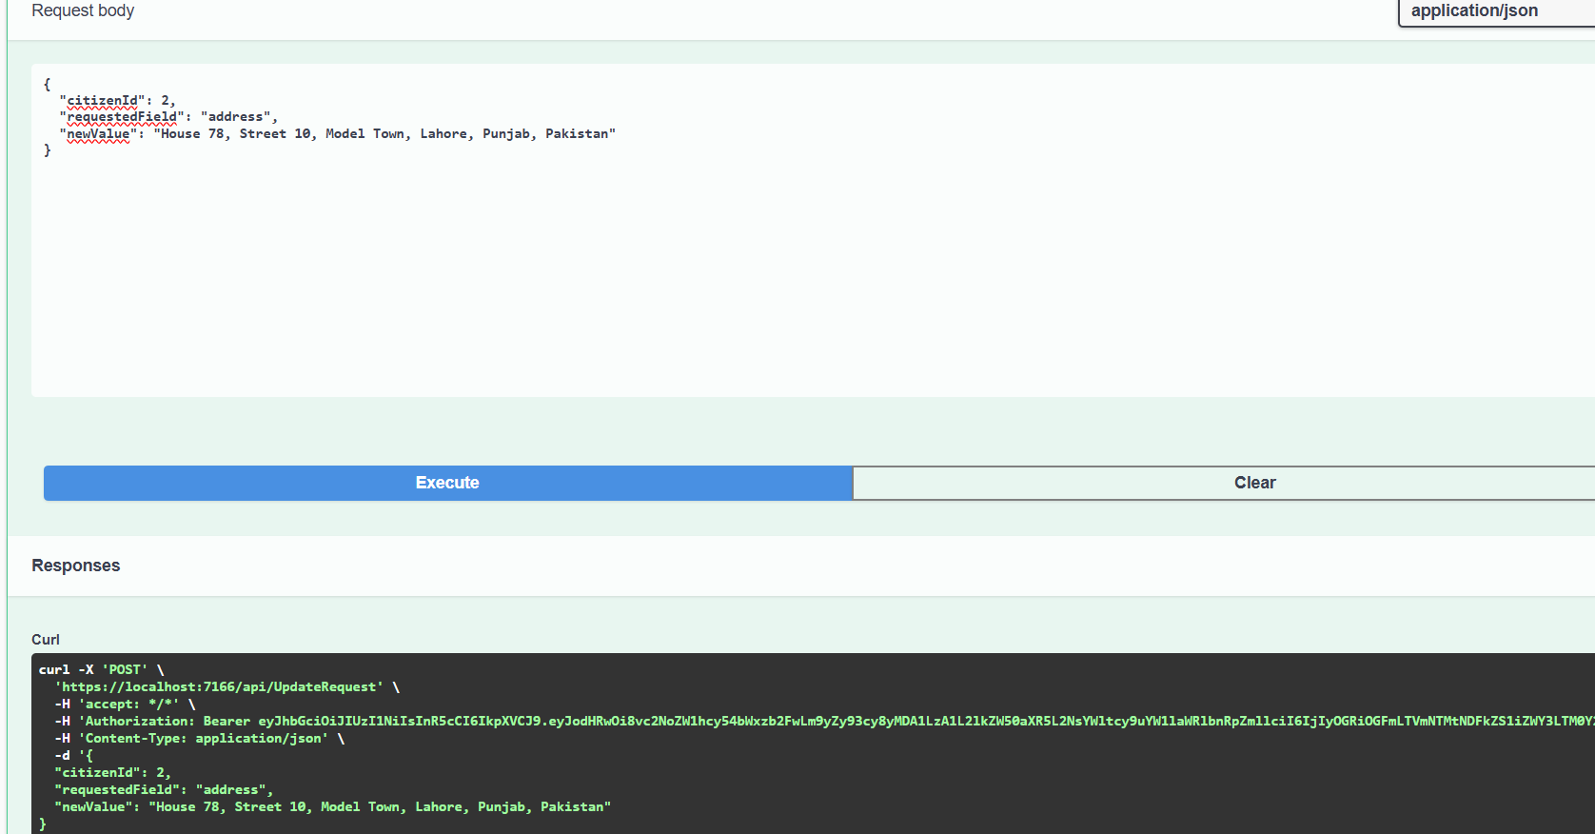

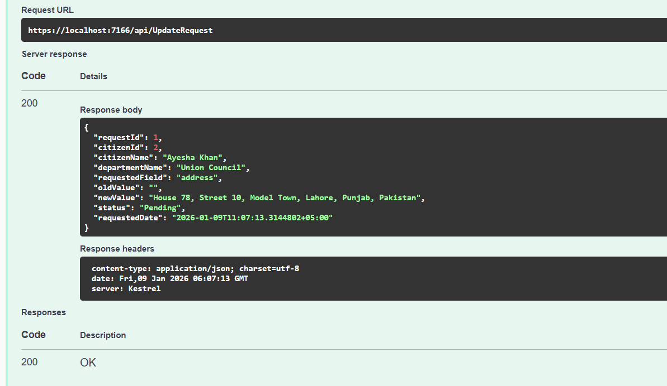

Get

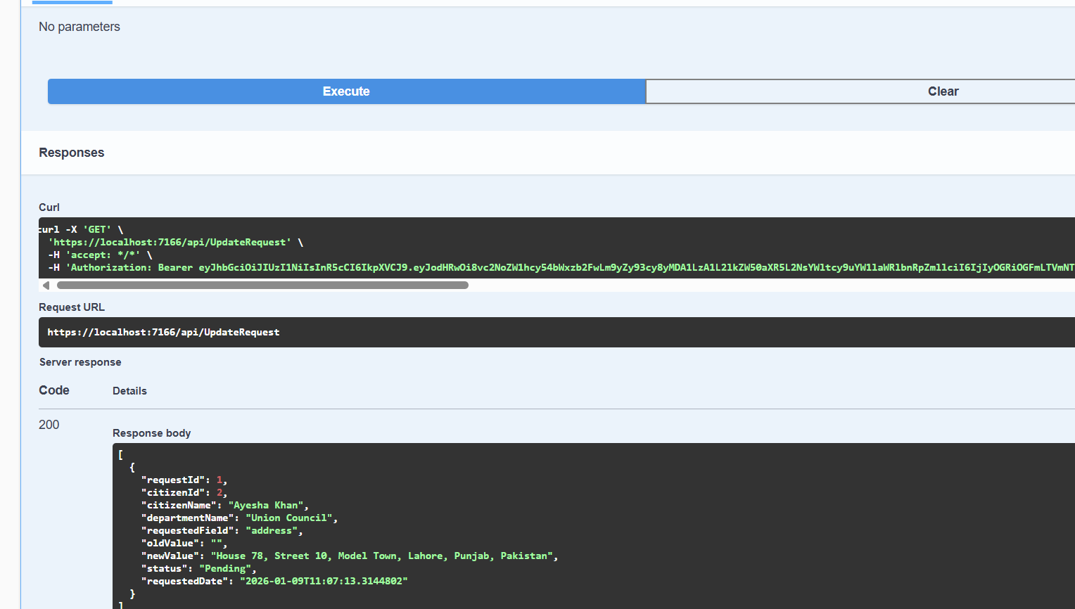

Update All

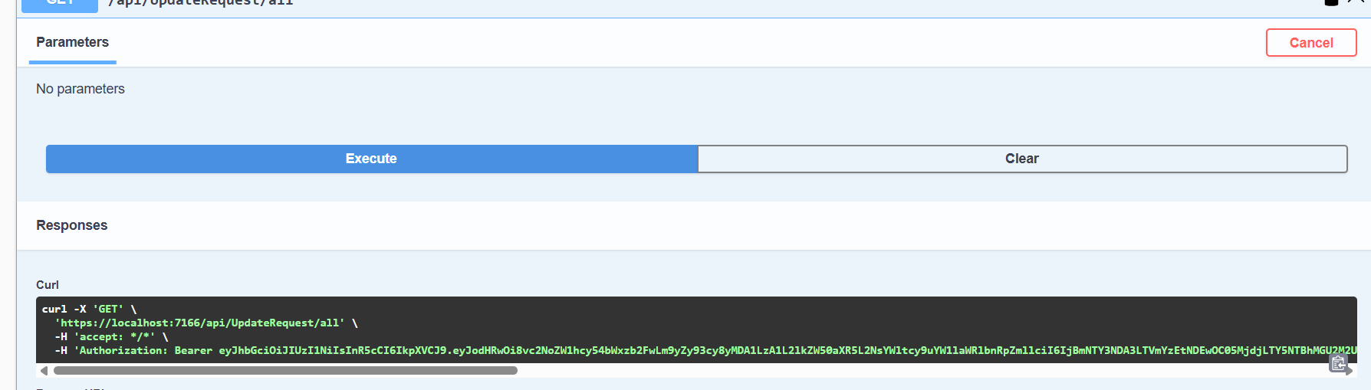

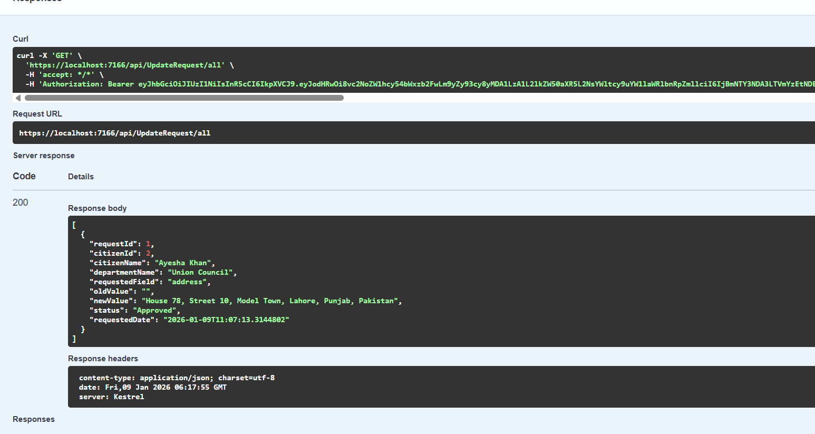

Approve

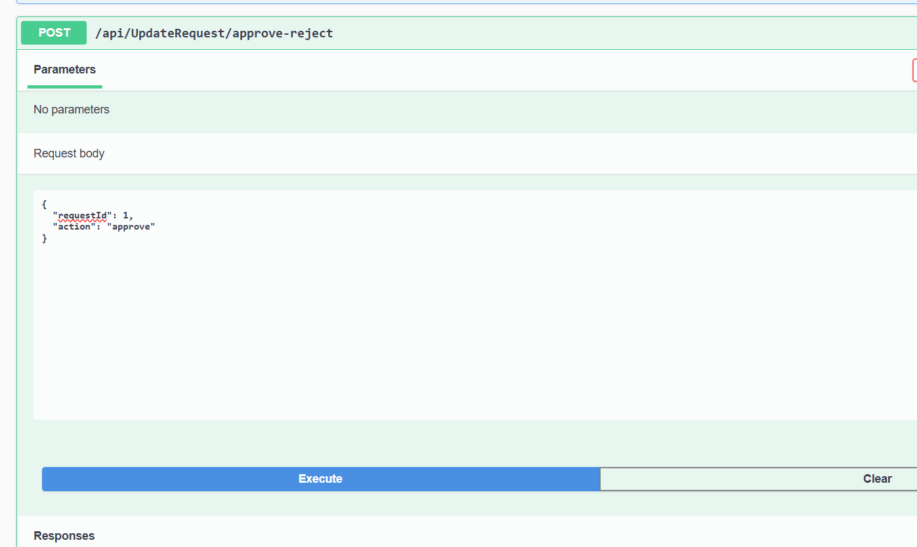

Verification

